“COMPARATIVE STUDY OF BISCUITS WITH ITC SUNFEAST ”
In
SMART BRIDGE INTERNZORGANIZATION,

SAMITHA DEGREE COLLEGE,RAJAHMUNDRY



TEAM MEMBERS :

DHARNALA SURENDRA
KONDETI VINAY
GANESHULA NAVEEN
DOREPALLI JYOTHI SRINIVAS

ABSTRACT

This report is about comparison of Sunfeast ITC with other biscuit manufacturers. This research report has been prepared on, “Comparative study of biscuits with ITC Sunfeast ” at Marketing Branch ITC, Shamli. My purpose of training was to determine key players operating in the biscuit Industry by estimating their sale volumes and critically evaluate distribution practices. According to my research, I found that ITC is performing well and is giving good competition to other popular brands in Shamli in a very efficient manner.
ACKNOWLEDGEMENT

“There is joy in work. There is no happiness except in the realization that we have accomplished something”
-Henry Ford

The making of any project requires contribution from many people, right from inception till its completion. In my case also, there had been a few people who have made this happen. It was not only learning but also an enriching experience.

I would like to thank Mr. MUKUL KAMBOJ, for being a source of inspiration and for the valuable suggestions provided throughout. His constant follow-ups and result orientation ensured that we successfully meet the deadlines.

I also thank my colleagues and friends for providing constant encouragement and help. Finally, I am grateful to my family members for their moral support and understanding.

“Teachers open the door, but you must enter by yourself”
PREFACE

The customer is king: finally ten years after the liberalization of India's economy began the marketplace has, suddenly, become frighteningly competitive. Not only have new players including a host of powerful translation, stormed into the country, there are more brands available then even before in every segment of every market. Befittingly, for the time in above 50 years since Independence, delivering the final verdict will be the customer who is already finicky about what will buy, in future, only that which meets her every desire. This demands more intimate understanding of the customer by the smart companies'. In my project I have tried to Estimate and Identify the Critical Success Factors for the availability of sunfeast biscuits in the convenience channel in Shamli for ITC.

PURPOSE OF THE TRAINING
PROJECT TITLE:
- Comparative study of biscuits with sunfeast ITC.
- To determine key players operating in the Industry by estimating their sale volumes and critically evaluate distribution practices.

THE STUDY SHALL ENTAIL THE FOLLOWING :

Complete understanding of the category and industry:
- The key players with brand wise volumes.
- Availability & Visibility figures of key players by channels.

Understanding of the distribution process and the components of the distribution chain:
- The players: Distributor, trade (Wholesale & retail), Salesman.
- Various channels and their dynamics (wholesale, convenience, grocer, tea stall/restaurant...)
- Distribution infrastructure (vehicle, sales force...)
- Distribution norms and practices: (inventory, billing, credit, delivery, frequency of service....)
- Strengths & Weaknesses of various players as regards distribution.

Understanding of various trade schemes in the market :
- Critically analyze the schemes as regards their design and effectiveness
- Recommendations for ITC to formulate a sales and distribution strategy to align with industry needs.


COMPANY PROFILE

ITC is one of India's foremost private sector companies with a market capitalization of nearly US $ 18 billion and a turnover of over US $ 4.75 billion. ITC is rated among the World's Best Big Companies, Asia's 'Fab 50' and the World's Most Reputable Companies by Forbes magazine, among India's Most Respected Companies by Business World and among India's Most Valuable Companies by Business Today. ITC also ranks among India's top 10 `Most Valuable (Company) Brands', in a study conducted by Brand Finance and published by the Economic Times.
ITC has a diversified presence in Cigarettes, Safety matches, Hotels, Paperboards & Specialty Papers, Packaging, Agri-Business, Packaged Foods & Confectionery, Information Technology, Branded Apparel, Personal Care, Greeting Cards and other FMCG products. While ITC is an outstanding market leader in its traditional businesses of Cigarettes, Hotels, Paperboards, Packaging and Agri-Exports, it is rapidly gaining market share even in its nascent businesses of Packaged Foods & Confectionery, Branded Apparel and Greeting Cards.

THE MISSION AND VISION STATEMENT

The ITC Mission



The ITC Vision



Awards & Accolades

- Golden Peacock Global Award for Corporate Social Responsibility in Emerging economies for 2005 by World Council for Corporate Governance for the e-choupal and social & farm forestry initiatives
- 2005 Golden Peacock Award for Excellence in Corporate Governance
- ITC Centre, Gurgaon awarded Platinum Green building rating by US Green Building Council -Leadership in Energy and Environmental Design
  - largest Platinum rated building in the world; 7th such building in the world
- Bhadrachalam paperboard unit :
  - adjudged ‘Greenest paper mill in India’ by The Centre for Science & Environment; won the Greentech Environment Excellence Gold Award
- ‘John Players’ adjudged the ‘Most Admired Shirt Brand of the Year’ at the Lycra® Images Fashion Awards (LIFA) awards in Jan’06
- SAM/SPG Sustainability Leadership Award conferred at the International Sustainability Leadership Symposium, Zurich
- Business Leadership Award for the Best Food Company, organized by NDTV Profit

PRODUCTS OF ITC

Today ITC is dealing in almost all the sectors of production. Some major areas of production are as follows:-

ITC
FMCG:
Cigarettes
Other FMCG
Hotels
Agri Business
Leaf Tobacco
Agri Commodities
Paperboard
Paper &
Packaging

FINANCIAL HIGHLIGHTS
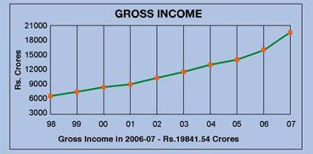
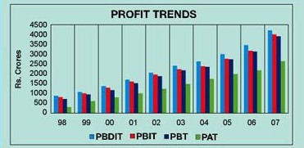

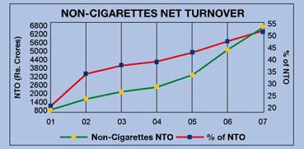
Figure: 1 Figure: 2

Figure: 3

ABOUT BISCUIT MANUFACTURERS

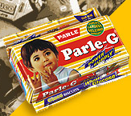

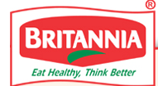



Parle 
Introduction
A long time ago, when the British ruled India, a small factory was set up in the suburbs of Mumbai city, to manufacture sweets and candies. The year was 1929 and the market was dominated by famous international brands that were imported freely. Despite the odds and unequal competition, this company called Parle Products, survived and succeeded, by adhering to high quality and improvising from time to time.
A decade later, in 1939, Parle Products began manufacturing biscuits, in addition to sweets and candies. Having already established a reputation for quality, the Parle brand name grew in strength with this diversification. Parle Glucose and Parle Monaco were the first brands of biscuits to be introduced, which later went on to become leading names for great taste and quality.
How Parle fought to make biscuits affordable to all.
Biscuits were very much a luxury food in India, when Parle began production in 1939. Apart from Glucose and Monaco biscuits, Parle did offer a wide variety of brands.
However, during the Second World War, all domestic biscuit production was diverted to assist the Indian soldiers in India and the Far East. Apart from this, the shortage of wheat in those days, made Parle decide to concentrate on the more popular brands, so that people could enjoy the price benefits.
Thankfully today, there's no dearth of ingredients and the demand for more premium brands is on the rise. That's why, we now have a wide range of biscuits and mouthwatering confectionaries to offer.
The strength of the Parle Brand
Over the years, Parle has grown to become a multi-million US Dollar company. Many of the Parle products - biscuits or confectionaries, are market leaders in their category and have won acclaim at the Monde Selection, since 1971.
The Quality Commitment
Parle Products has one factory at Mumbai that manufactures biscuits & confectioneries while another factory at Bahadurgarh, in Haryana manufactures biscuits. Apart from this, Parle has manufacturing facilities at Neemrana, in Rajasthan and at Bangalore in Karnataka. The factories at Bahadurgarh and Neemrana are the largest such manufacturing facilites in India. Parle Products also has 14 manufacturing units for biscuits & 5 manufacturing units for confectioneries, on contract.

The Marketing Strength
The extensive distribution network, built over the years, is a major strength for Parle Products. Parle biscuits & sweets are available to consumers, even in the most remote places and in the smallest of villages with a population of just 500.

PARLE BISCUITS AVAILABLE IN MARKET

Name gm Flavour price

GLUCOSE

Parle G 19 Rs 1
44 Rs 2
- Rs 3
- Rs 4
- Rs 10
- Rs 20
PREMEUM GLUCOSE

Milk shakti 75 Rs 5 150 Rs10

Parle 20-20 75 Rs 5
- Rs10
- Rs 22
CREAM

Parle Cream 90 orange Rs 5
90 ilachi Rs 5
90 mango Rs 5
90 pineapple Rs 5
Bonn-Bonn 90 chocolate Rs 10
180 chocolate Rs 18
SNACKY

Monaco 75 Rs 7
- Rs 10

Parle Namkin 75 Rs 5

Krack Jack 75 Rs 7
- Rs 10
MARIE

Digestive Marie 182 Rs 13

HIDE & SEEK
Hide & Seek 25 Rs 4
- Rs 8
- Rs 15

BRITANNIA

COMPANY OVERVIEW
The story of one of India's favourite brands reads almost like a fairy tale. Onceupon a time, in 1892 to be precise, a biscuit company was started in a nondescript house in Calcutta (now Kolkata) with an initial investment of Rs.295. The company we all know as Britannia today.
The beginnings might have been humble-the dreams were anything but. By 1910, with the advent of electricity, Britannia mechanised its operations, and in 1921, it became the first company east of the Suez Canal to use imported gas ovens. Britannia's business was flourishing. But, more importantly, Britannia was acquiring a reputation for quality and value. As a result, during the tragic World War II, the Government reposed its trust in Britannia by contracting it to supply large quantities of "service biscuits" to the armed forces.
As time moved on, the biscuit market continued to grow… and Britannia grew along with it. In 1975, the Britannia Biscuit Company took over the distribution of biscuits from Parry's who till now distributed Britannia biscuits in India. In the subsequent public issue of 1978, Indian shareholding crossed 60%, firmly establishing the Indianness of the firm. The following year, Britannia Biscuit Company was re-christened Britannia Industries Limited (BIL). Four years later in 1983, it crossed the Rs. 100 crores revenue mark.
On the operations front, the company was making equally dynamic strides. In 1992, it celebrated its Platinum Jubilee. In 1997, the company unveiled its new corporate identity - "Eat Healthy, Think Better" - and made its first foray into the dairy products market. In 1999, the "Britannia Khao, World Cup Jao" promotion further fortified the affinity consumers had with 'Brand Britannia'.
Britannia strode into the 21st Century as one of India's biggest brands and the pre-eminent food brand of the country. It was equally recognised for its innovative approach to products and marketing: the Lagaan Match was voted India's most successful promotional activity of the year 2001 while the delicious Britannia 50-50 Maska-Chaska became India's most successful product launch. In 2002, Britannia's New Business Division formed a joint venture with Fonterra, the world's second largest Dairy Company, and Britannia New Zealand Foods Pvt. Ltd. was born. In recognition of its vision and accelerating graph, Forbes Global rated Britannia 'One amongst the Top 200 Small Companies of the World', and The Economic Times pegged Britannia India's 2nd Most Trusted Brand.

BRITANNIA BISCUITS AVAILABLE IN MARKET

Name gm Flavour Price

GLUCOSE

TIGER 16 Rs 1
- Rs 2
67 Rs 3
- Rs 4

MILK BIKIS 67 Rs 5
NICE 200 Rs 15
CREAM

T-CREAM 85 Kesar Rs 5
85 orange Rs 5
85 Rose Rs 5
TREAT 180 Chocolate Rs 22
100 Chocolate Rs 12

MARIE

GOLD 198 Rs 13

PREMIUM QTY

GOOD DAY 92 Butter Rs 10
92 Kashew Rs 12

LITTLE 87 Rs 10
HEART
50-50 50 Rs 5

NUTRI 250 Rs 35
CHOICE
DIGESTIVE
100 Rs 14

SUNFEAST 

Introduction to the Biscuit segment of ITC

ITC launched delicious biscuits of international quality under the Sunfeast range on 28th July 2003. The biscuits were launched after a great deal of market research. Sunfeast Glucose, Sunfeast Marie and Dream Cream biscuits were the first to make an appearance in the market. In a short span of 3 years Sunfeast has launched many new varieties and has its presence in almost all types of biscuit categories

SUNFEAST BISCUITS IN MARKET

GLUCOSE | NET PTR. | MRP.
GL – 16 GM | 0.91 | 1
GL – 44 GM | 1.82 | 2
GL – 66 GM | 2.73 | 3
GL – 88 GM | 3.64 | 4
GL - 220 GM | 9.10 | 10
GL - 440 GM ( FAMILY PACK) | 18.38 | 20
FIT * KIT | NET PTR. | MRP.
VITAMIN & PROTEIN 75 GM | 4.51 | 5
MULTI GRAIN 100 GM / WITH PROMO | 8.93 | 10
BENNE VITA FLAXSEED 92 GM | 17.87 | 20
MARIE | NET PTR. | MRP.
MARIE-LIGHT / ORANGE MARIE - 183 GM | 11.62 | 13
MARIE – 366 GM ( FAMILY PACK) | 21.29 | 24
PREMIUM CREAM | NET PTR. | MRP.
PINE APPLE CREAM 90 GM | 8.93 | 10
MANGO CREAM 90 GM | 8.93 | 10
ELAICHI CREAM 90 GM | 8.93 | 10
BUTTERSCOTCH CREAM 90 GM | 8.93 | 10
STRAWBERRY CREAM 90 GM | 8.93 | 10
ORANGE CREAM 90 GM | 8.93 | 10
MILY MAGIC CREAM 90 GM | 10.72 | 12
BOURBON CREAM 88 GM | 10.72 | 12
BUTTERSCOTCH 180 GM / 200 GM | 16.08 | 18
ORANGE CREAM 180 GM / 200 GM | 16.08 | 18
STRAWBERRY CREAM 180 GM / 200 GM | 16.08 | 18
BOURBON CREAM 176 GM | 19.86 | 22
DARK FANTACY | NET PTR. | MRP.
DARK FANTASY -150 GM | 25.62 | 30
DARK FANTASY -240 GM | 50.89 | 60
DARK FANTASY -300 GM | 51.23 | 60
SPECIAL CREAM | NET PTR. | MRP.
SUNFEAST SPECIAL ORANGE CREAM – 75GM | 4.55 | 5
SUNFEAST SPECIAL ORANGE CREAM - 150GM | 9.10 | 10
SUNFEAST SPECIAL ORANGE CREAM - 250GM | 13.65 | 15
SUNFEAST SPECIAL CHOCO CREAM - 75GM | 4.55 | 5
SUNFEAST SPECIAL CHOCO CREAM – 150GM | 9.10 | 10
SUNFEAST SPECIAL CHOCO CREAM – 250GM | 13.65 | 15
SPECIAL COOKIES | NET PTR. | MRP.
SUNFEAST SPECIAL BUTTER - 75 GM | 4.47 | 5
SUNFEAST SPECIAL BUTTER - 150 GM | 8.93 | 10
SUNFEAST SPECIAL BUTTER - 250 GM | 16.25 | 18
SUNFEAST SPECIAL CASHEW - 75 GM | 5.36 | 6
SUNFEAST SPECIAL CASHEW - 150GM | 10.72 | 12
SUNFEAST SPECIAL CASHEW - 250GM | 18.05 | 20
SUNFEAST SPECIAL COCONUT - 72GM | 4.51 | 5
SUNFEAST SPECIAL COCONUT – 165GM | 8.93 | 10
SNACKY | NET PTR. | MRP.
SNACKY SALTED 75 GM | 13.28 | 7
SNACKY CHILLI 75 GM | 6.25 | 7
SWEET N SALTY - 75 GM | 6.25 | 7
SNACKY SALTED 110 GM | 8.93 | 10
SNACKY CHILLI 110 GM | 8.93 | 10

PROJECT PLAN IN TERMS OF FIELD STUDY OF THE PROJECT
The entire project activity was divided into weekly milestone to ensure the following:

- Complete framework of the project
- Completion of the project on time
- To be economize on time
- To make continuity of the project
- Timely completion of the weekly schedules

WEEK- 1
- Visiting the marketing branch of ITC.
- Meeting the project guide to make a scheduled plan for the coming week.
- Visiting WD (wholesale dealer) point of ITC to know their working process.

WEEK-2
- Making a general survey of the market (wholesaler, retailer& customer) to find out the top selling brands with in which the study has to be done.
- Five brands came in picture which is most operating brands in the market along with two brands which operates only in some areas of Shamli.
WEEK-3
- Designing a questionnaire to get information regarding the top selling brand out of the chosen three brands.
- Divided Shamli in four zones to cover one area in one week.

WEEK- 4,5,6,7
- Interviewed retailers, wholesalers & consumers in first zones which covers the areas of Shamli.

WEEK-8
- Analysis & interpretations
- Suggestions & Recommendations.

INTRODUCTION OF RESEARCH

This chapter focuses on the methodology and the techniques used for the collection, classification and tabulation of data. It sheds light on the research problem the objective of the study its limitations and the hypothesis that have evolved for the study. The later part of the chapter explains the manner in which the data is collected, classified, tabulated and analyzed so as to reach to conclusive results.

Research Methodology has many dimension, it includes not only the research methods but also considers the logic behind the methods used in the context of the study and explains why only a particular method or technique has been used so that search lend themselves to proper evaluation. Thus in a way it is a written game-plan for concluding research. Therefore in to design a research problem it is necessary to design a research methodology for the problem as the same may differ from problem to problem.

OBJECTIVES OF THE STUDY
On the basis of my study objectives and scope of the study is as follows :

1) To study the brand preferences for different biscuits.
2) To find the extent of brand loyalty that exists among different biscuit brands.
3) To study the influence of various aspects on buying behaviour and to conduct a comparative analysis across different respondents.
4) To estimate the biscuits industry in Shamli Area.
6)Collection of data and representing them graphically.
7)To analyze the data collected the according to it some recommendations.
8)To suggest the distribution system for ITC and to point out the strong points of it.

Research Description

HYPOTHECATION OF THE STUDY
Hypothesis is considered as the principal instrument in research. It enables to make probability statement about population parameters.
The study will be conducted under the broad framework of the following Hypothecation.
- Buyer's (customers) give equal importance to different factors while deciding about the purchase of biscuits.
- Buyers consider price.
- Different media knowledge and in influencing the buyer.
- Children at home are a major factor in deciding a particular brand of biscuits.
SCOPE OF STUDY :
The scope of study has been limited to sample size of 100 Retailers due to the time and the cost constraints. However, the scope of the study with respect to geographical area is restricted to the city of Shamli.
NATURE OF STUDY:
It is an exploratory research and the basic aim of exploratory research is to gain familiarity with the phenomena or to achieve new insights into it. So the study has tried to find out the psychograph of the consumer and to find, who have the maximum influence on the decision making of the consumers.

RESEARCH DESIGN
To study the consumer behaviour with respect to Brand Preference in Different Brands of Biscuits sample survey method has been chosen sample survey method has been chosen because of its benefits over other methods. It allows direct contact with the customer and therefore customer psycho can be studied more efficiently.
To collect data a number of techniques are employed under the sample survey method like questionnaire, observation and interview schedule. The increasing of questionnaire and schedule it probably due to increased emphasis by social scientists on quantitative measurements to uniformly accumulated data.

SELECTION OF SAMPLE
Social phenomenon being very vat, it becomes impossible to contact each and every individual of the population due to limitations of essential resources like time and money. Therefore, the study is preferable borrowed down to a representative sample to make the study more manageable.
Keeping in view of the objectives and resource limitations of the study, samples of 100 retailers were considered.
The selected sample is representative of the population and is accurate and practicable.

SAMPLING PLAN
The following factors have to be decided with in the scope of sampling plan.
1. SAMPLING UNIT
First step in developing any sample design as to clearly define the set of objectives technically called the universe to be studied. The universe can be finite or infinite. My universe was finite as I opted for specific city Shamli.
2. SAMPLE SIZE :
This refers to the people surveyed although large samples are more reliable but due to shortage of time and money a small representative of 100 shopkeepers were chosen.
3. SAMPLING PROCEDURE :
This refers to procedure by which respondents should be chosen. In order to obtain a representative sample a probability sample of population was drawn.
4. SAMPLE DESIGN:
Because the primary sampling unit represented a cluster of unit based on geographic area of Shamli.

PROBLEM FORMULATION
ITC Ltd wants to increase its sale of it’s biscuits produced under the brand sunfeast. For this purpose a lot of research was going on in many parts of north India. So Shamli area was given to me to do the research work.
This research is basically done to explore the biscuit market of the in Shamli. This study should entail many things like which are the major operating brands of biscuits in the market, who are the major companies operating in the market of Shamli, what are the distribution norms & practices & above all what are the various trade schemes on the product in the market of Shamli.
The study should cover all important element of the market, which give useful information to ITC for making available the biscuits in the convenience channel in the market of Shamli.
RESEARCH PROPOSAL
Some shopkeepers were interviewed in the course of the study to gather the information to fulfill the stated objectives.
During my survey, I found that there are three types of convenience outlets. These are:-
- Those outlets, which are not at all interested in keeping the biscuits, not even local ones.
- Those outlets, which are interested in keeping only the local biscuits.
- Those outlets, which are interested in keeping branded and local biscuits both.

Limitations of the study

No research work is complete in itself. There are certain factors which are beyond the control of the researcher but do affect the study. A few limitations are as follows: -

- Due to personal biasness of the individuals involved in the study, the results thus obtained may also be not so much accurate.

- Another factor was short span of the time.

- The sample size for consumers is small; it may not be the true representation.

- Analysis is based on the tables only.

ANALYSIS & INTERPRETATION

The data, which is collected through the survey, is analysed and interpretation is given on the basic of analysis.

MARKET SHARE OF THE BISCUIT COMPANIES IN SHAMLI ON THE BASIS OF THE SURVEY

NAME OF COMPANY | PERCENTAGE OF MARKET SHARE  (out of 100)
PARLE | 40%
BRITANNIA | 35%
ITC SUNFEAST | 20%
OTHERS | 05%

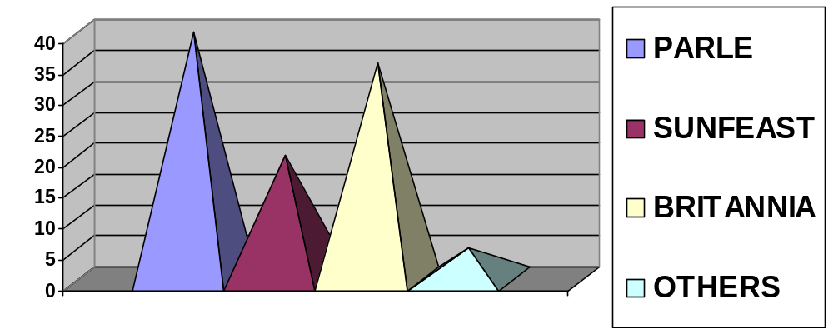

It shows that biscuit market in the Shamli is a very competitive one. As far as the big operators are concern PARLE leads the market with having 40% share in the convenience channel Britannia which is the next most operating brand in the market is having a share of 35% in the sale & convenience channel. ITC is also not to far away, it also has the market share of 20%. As the data also shows that all three brands are in stiff competition with each other in the convenience channels of Shamli.

SURVEY OF DIFFERENT BISCUIT SEGMENTS IN SHAMLI

  - GLUCOSE
Company | No. Of Respondents
Sunfeast | 15
Parle | 60
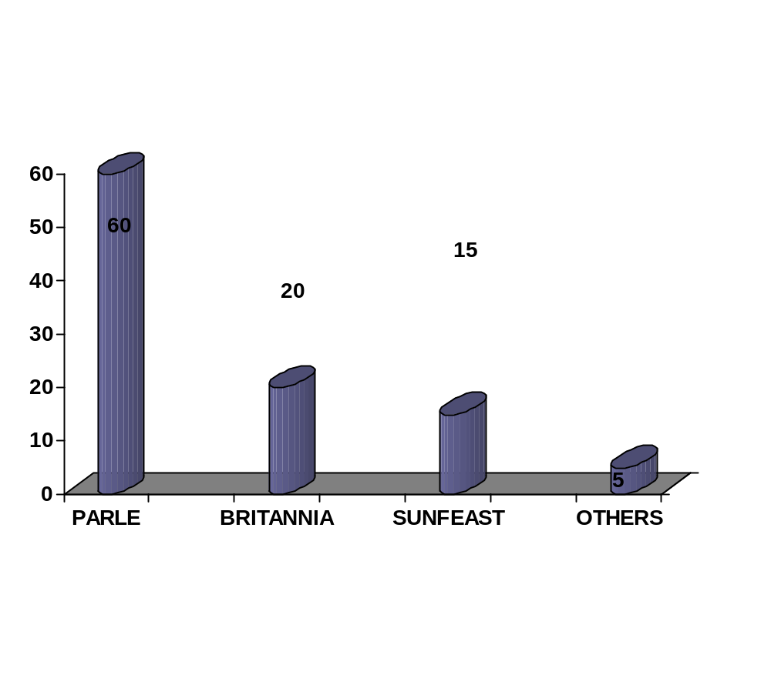Britannia | 20
Others | 5

FINDINGS
It is clear from the survey that parle holds the glucose segment completely in shamli due to it’s goodwill.Whereas it’s competitors ITC and Britannia are far behind in this segment.

2)PREMIUM CREAM

Company | No. Of Respondents
Sunfeast | 20
Parle | 45
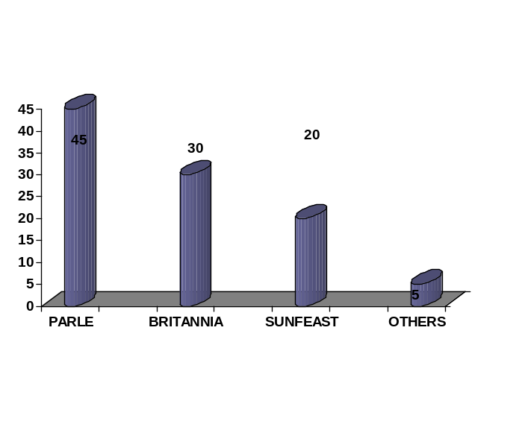Britannia | 30
Others | 5

FINDINGS
It is clear from the survey that parle holds the PREMIUM CREAM segment in shamli .It is because they are giving more (gm) in this segment at same price of it’s competitors.

3)COOKIES

Company | No. Of Respondents
Sunfeast | 25
Parle | 25
Britannia | 45
Others | 5
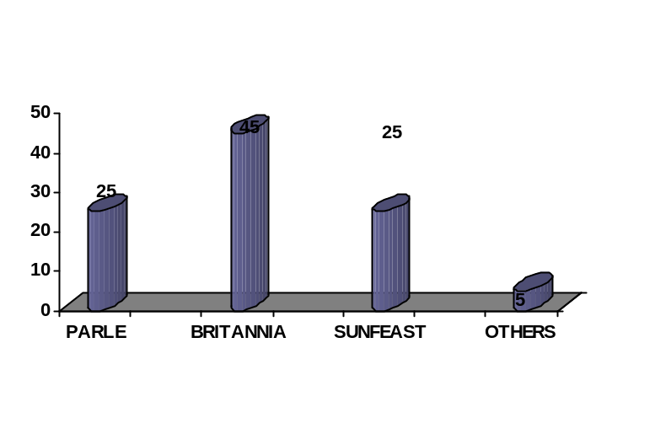

FINDINGS
It is clear from the survey that Britania holds the COOKIES segment in shamli due to the unbeatable taste of GoodDay biscuits.Whereas it’s competitors ITC and Parle are still improving in this segment.
4)MARIE

Company | No. Of Respondents
Sunfeast | 10
Parle | 35
Britannia | 50
Others | 5
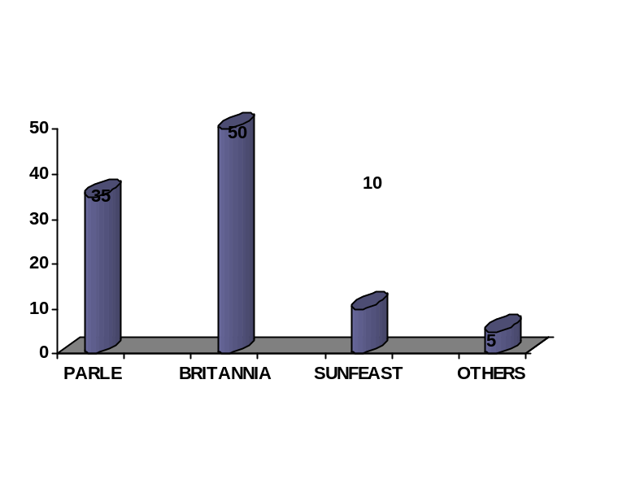

FINDINGS
It is clear from the survey that Britania holds the MARIE segment in shamli as they are producing many variants in Marie segment which attract the people.Whereas it’s competitors ITC and Parle don’t have many variants in this category.

5)SNACKY
Company | No. Of Respondents
Sunfeast | 27
Parle | 35
Britannia | 35
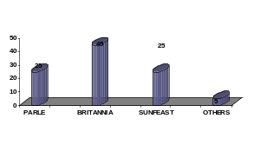Others | 3

FINDINGS
It is clear from the survey that Britania & Parle holds the SNACKY segment in shamli.Whereas it’s competitors ITC is improving. Main reason for ITC set back in this segment is poor advertising according to survey.

BUYING PREFERENCE OF THE RETAILERS IN SHAMLI

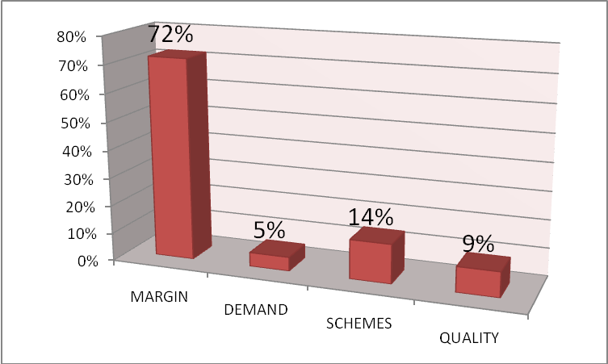

REASON
It gives a clear picture ,that the retailer is attracted to sell those items which has greater margin.it is because mostly all the brands have simmilar MRP and weightage of their product if compared with each other in every catogory of biscuits (cream or glucose). Moreover there is not much difference of taste also.

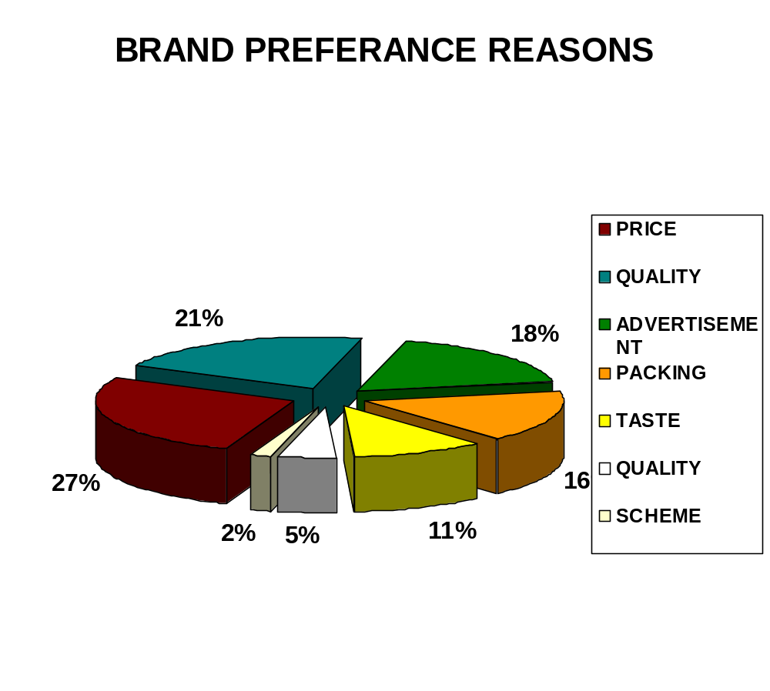

Which advertisement media put more impact on your buying decision?
Media | No. Of Respondents
Newspapers | 25
T.V | 45
Internet | 10
Others | 20
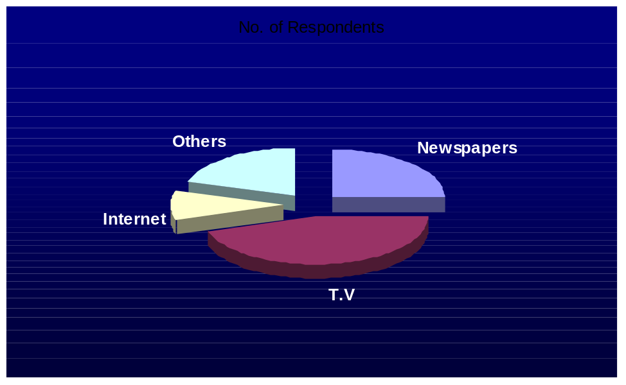

Interpretation: The above table and graph shows, that out of 100 respondents 45 respondents find T.V advertising media are much effective than newspapers, internet or any others.

In your view, what will be the future of ITC Sunfeast?

Status | No. Of Respondents
Excellent | 25
Good | 40
Average | 30
Poor | 5



Interpretation: The above table and graph shows that out of 100 respondents, 40 respondents think that the future of these mobile companies will be good, then 30 respondents think it will be average, then 25 respondents find it excellent and only 5 respondents are having the view of poor future of mobile companies.

Availability
The availability of ITC’s Sunfeast biscuits is satisfactory however, there is still a lot to improve. A total of 100 RO’s were covered during the survey, out of which the product was available on 45 RO’s. The overall availability of the product is 45 %. For a brand like ITC who is known for its excellent market coverage this can not be considered a very good figure.

- Quality

Quality is what every one of us look forward to before buying any product. ITC is committed to provide quality products to its customers and we all know this fact. Shockingly, during the survey there were a number of complaints received regarding the quality of the biscuits. Some of them are:

- There were a lot of complaints regarding the weightage of biscuits. People were complaining that the weight of biscuit packets is reduced by the company in a frequent manner.
Example- glucose biscuit of Rs 2 is reduced to 38.5 gm from 40gm.
Also sunfeast butter has been reduced to 128gm from 150g @ Rs10

- Breaking of biscuits during distribution was also reported in the majority of areas covered during the survey.

- There were also complaints regarding the quality of biscuits.

- Trade/Promotional Schemes

ITC is one of the biggest manufacturer in the biscuit industry. Its direct competition with the big fishes like parle and Britannia . ITC is spending very less on advertisement, which is the source of information for mass, where as Parle and Britania has widely spread advertising campaign so it is a word of mouth for the people. They pass this cost advantage to the retailers and provide them better margins and other schemes as compared to ITC.

- Brand Awareness

Any brand’s success is measured in terms of its Brand Awareness. The more the brand awareness, the more will be the demand which means increased sales. Any company can not establish a brand unless and until its brand awareness is good in the market.
During the survey it was also found that there were a large number of retailers who were completely unaware from the fact that ITC also markets premium quality biscuits like DARK FANTASY & BOURN BON CREAM. It means that there are lot of irregularities and loop holes in the distribution system.
POSSIBLE REMEDIES

- Distribution

- Increase the coverage of retail outlets in the market.

- The sales persons need to be more aggressive in their approach towards selling ITC’s Sunfeast biscuits. A Workshop may be organized for them where they can get valuable marketing tips from top officials.

- The sales persons must ensure that they pay regular visit to RO’s and the supervisor must keep a hawk eye on these issues to ensure strict adherence.

- Distribution of tobacco based product and non tobacco based products should be divided, as it is quite difficult for a DS to carry the complete product range to meet the demand of a particular area.

- Areas covered by SCP’s, should be covered by distribution van at least once in a week to ensure the proper supply to whole sellers.

- The Supervisor needs to increase the frequency of visits, this will facilitate in sorting out a few complaints of the retailers i.e. regarding displays and D&D. This will also help in tracking more and more whole sellers and retailers in that particular area.

- Availability

The availability can be improved by ensuring that:

Regular supply of the items should be properly maintained by enhancing supply chain network.

- The sales person must pay regular visit to the retailers.

- The DS needs to encourage the retailers to sell ITC’s Sunfeast and ask for orders each time in their visits. It was seen that those retailers who were initially selling sunfeast products stopped selling it because the DS didn’t asked again for the orders and were irregular in their visits .

3. Convert prospective customers (retailers & whole sellers) into actual customers as there are a lot of retailers & whole sellers who can sell ITC Sunfeast Premium biscuits, but were not provided with the proper information (as there were few RO’s where sales took place first time after convening them).

4. DS should be provided with minimum sales target (quantitative - based on the past sales record and territory potential)

5. Additional incentives can be granted on the sale of sunfeast biscuits.

- Quality

High level quality check is required at the time of

- Manufacturing process – to control splitting problem and to correct the quality of sunfest biscuits.

- Packaging – as to ensure the proper quantity

- Quality of the product should be unmatched, some thing innovative need to be done

LEARNING EXPERIENCE DURING THE TRAINING
My, project entitled “COMPERATIVE STUDY OF BISCUITS WITH SUNFEAST ITC” was given to me for my summer training in I.T.C. It has been a great experience, while during a training in Shamli city. In, my life it was my first experience to get people knows of different categories through survey. After doing my survey, I learnt that at each and every level there is a competition.
GAINS
- The first and main thing I learnt about the distribution channel of different companies of biscuits.
- About handling the work force.
- How to get people convince for buying the product.
- How to increase the sales force.
- About the current situation of market condition.
LOSS
- During the training some of the sample respondents does not give their full information and also hesitate to answer the questions.
- The sample selected by the research was of approximately 100 convenience outlets so due to a small sample out of a big universe, the results may not be completely correct.
It was too hot outside and places were far from each other.

- Website of different Companies
http://www.itcportal.com
http://www.outlookbusiness.com
http://www.expressindia.com
http://www.icmr.org
http://www.moneycontrol.com
http://www.google.com
- News Papers
  - I.T.C. News
  - The Economic Times

THANK YOU

